Cambodian Peacekeeper Killed, Three Missing in Central African Republic
BY KUCH NAREN | MAY 9, 2017
The Cambodia Daily
A Cambodian peacekeeper was killed—possibly beheaded—by rebels in the Central African Republic on Monday night and three others are currently missing, Prime Minister Hun Sen and the South Korean ambassador announced this morning.
“We are sorry…. I take this opportunity to offer condolences to our forces in Central Africa, who were…attacked by rebels, causing one death, and three others have gone missing,” Mr. Hun Sen said during a speech in Tbong Khmum province.
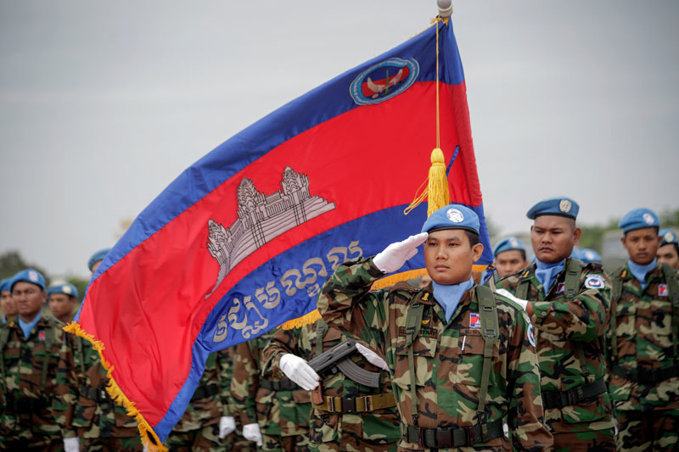A member of the Royal Cambodian Armed Forces salutes at a ceremony ahead of the deployment of 184 soldiers on a peacekeeping mission to Lebanon in 2014. (Siv Channa/The Cambodia Daily)
The murdered soldier was a captain, Phoem Sam from Siem Reap province, he said. (Malinda Kosal, spokeswoman for the U.N.’s National Center for Peacekeeping Forces, was awaiting further details but confirmed that one soldier, who she believed to be named Im Som, had been shot dead and three were missing.)
The premier added that forces in the Central African Republic were searching for the three missing soldiers, whom he did not name.
Long Dimanche, ambassador to South Korea, wrote on his Facebook page that the captain had been beheaded by rebels.
“I would like to inform [you] of shocking and sad news of a Cambodian peacekeeper who lost his life in Central Africa in a peacekeeping mission in the framework of the United Nations. Rebels have beheaded him,” he wrote.

